**Submit your compressed folder with all the required college material on or before the due date. The website project must be uploaded, presented and code explained in order for marks to be awarded.**

**Complete and Submit the Website Project Check List with report**

|  |
| --- |
| **☐ *** GitHub URL Progress upload of web site navigation and 3 pages – Week9** |
| **☑ Project Report, Upload zipped folders all website files with report, (*place college project on front page, no personal information to be included, public domain images, no images of minors, reference to all content source, individual effort* )** |
| **☑ Minimum of 4 HTML Page Website** |
| **☑ HTML5 standards and recommended page layout structure** (header,main,aside,article,section,footer) |
| **☑ Include Meta data – description, keywords, author - Maximise SEO** |
| **☑ Include font family for body of page** |
| **☑ Appropriate use of External Style Sheet – Recommended CSS** |
| **☑ Appropriate Example using Internal Styling on HTML page** (an example) |
| **☑ Appropriate Example using use of inline Styling** (an example) |
| **☑ Home page content aligned to each other and visually attractive** |
| **☑ Consistency of design on all pages above fold, aligned, use of fonts, colour etc.** |
| **☑ Appropriate use of Headings (h1, h2, h3, h4)** |
| **☑ Appropriate use of Colours, easy to read and complimentary colours** |
| **☐ Include an article or section with css that displays 2 or 3 columns** using CSS Multi-column Properties |
| **☑ Clear, consistent and align content on page** *(reference all sources)* |
| **☐ Include public domain images (***with at least on image floated with text or flexbox***)** |
| **☐ Use of background image** |
| **☐ Include table of data/information** |
| **☑ Include and display as lists both ordered and unordered** ( with different shaped bullet points) |
| **☐ Include favicon and logo on your website** |
| **☐ Include a contact form Display values entered in form and include red * beside required/mandatory input fields** |
| **☐ Verify data collected on contact form, using get and data attached to URL** (Use the method get to display values entered on form will be appended to URL and passed to server <form <action="http://foo.com" method="get">) |
| **☐ Include google maps and suitable video** (include reference if YouTube videos are used) |
| **☑ Footer information include html entity** Copyright© year **and Footer Menu** |
| **☐ Include Internal Links and External Links – Responsive webpages(70%)** |
| **☑ Include Appropriate use of both CSS Class and Id selectors** |
| **☑ Appropriate use content layout using margins, paddings and borders (<br**> only used to split text on separate line eg address or contact form) |
| **☐ Additional Features __________________** |
| **☐ W3C HTML (in report)** <https://validator.w3.org/nu/#file> |
| **☐ Report include Proposal, Declaration of your own work , URL to Github, Rough Sketch of layout design, brief descriptions of the web site its pages and sources for information and Validator results-** |
| **☐ Website appearance, design and Content** [**https://webdesignledger.com/10-signs-of-a-user-focused-design/**](https://webdesignledger.com/10-signs-of-a-user-focused-design/)[**https://webdesignledger.com/20-dos-and-donts-of-effective-web-design/**](https://webdesignledger.com/20-dos-and-donts-of-effective-web-design/) |

*Please note, due a word update during this assignment the intractability of the checkbox embeds above broke. Apologies for any inconvenience this causes.

Report

**Initial Project Plan**  
  
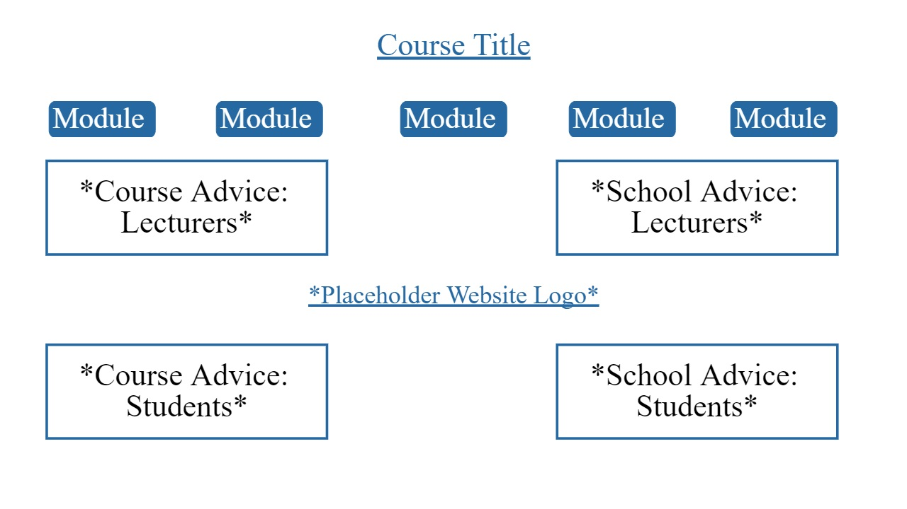

**Sign In**

This is a demonstration of a contact form which is intended to serve as a mock of my websites sign in page. A user would input the necessary/desired information into the interactable areas and then press the submit button to record their information and be taken to a version of the home page that is tailored to their specific course and its framework. I was unable to make the submit button into a navigation link so I placed a nav link to the home page with the “Continue” text in the centre. The content of this page is mostly abstract and superfluous as I intended the entire website to be a demonstration of its fundamental layout and intent rather than a hypothetical example of itself with implemented proper content.

There exists both radio and checklist button selection as well as two different sizes of input fields on this page. The extensive button lists exist to facilitate and demonstrate the two internal links in this page.

**Index**

This is the home page of this website template; it would serve as the first page shown to a logged in user and give guides and advice related to their school life (both top sections) and course as a whole (both bottom sections) from both lecturers (left sections) and students (right sections).

There exists an ordered list, embedded video, and scrollable article on this page.

**Page 1**

This is the page that would serve as an advice and tutorial hub for the first module in a logged in user’s course. Each module page is divided into four sections, two of which intended for use by lecturers (left) of the course and two of which intended for use by students (right) - past and present – of this course.

In all module pages and the home page, the lecturer written boxes and student written boxes use different font families.

**Page 2**

This is the page that would serve as an advice and tutorial hub for the second module in a logged in user’s course.

An example of a table is implemented in the bottom right (student) section of this page.

**Page 3**

This is the page that would serve as an advice and tutorial hub for the third module in a logged in user’s course.

There exists an unordered list of external links on this page.

**Page 4**

This is the page that would serve as an advice and tutorial hub for the fourth module in a logged in user’s course.

There exists an embedded google maps page in the bottom right section of this page.

**Page 5**

This is the page that would serve as an advice and tutorial hub for the fifth module in a logged in user’s course.

There exists a demonstration of columns in the top right section of this page.

CSS

Please note, many “errors” from the validation were not errors at all such as instances of the “/” character in the website links giving an error that advised to place a “>” after it as one would do in a closing tag despite the fact that that would render the link unusable. Additionally, all instances of the “duplicate id” error are entirely intentional as I needed to use “lecturertext” and “studenttext” twice on each module page.

**References**

All sourced code was taken from w3schools.com and in-class exercises and then adapted to my needs. Little if any of it should resemble the original versions of itself in any way save for its unavoidable fundamentals.

All three public domain images were taken from in-class exercises as these were guaranteed to be safe to use.

**URL**

https://seanriain.github.io/websiteprojectfinal.github.io/